Part 1c Group Presentation to Class

## **Group 1**

### Nawal Ahmed

### Rahul Kotian

### James Pi

### Siian Rancharan

Omkar Salokhe

**1g and h. After answering question 1g and 1h, answer and present the following.**

**Will the total slack of your project in the summary task always be 0?**

**No**, it can be a positive or a negative number. A negative number does imply that the project needs better management as the project cannot be called a success if it is set to finish beyond the deadline. A positive number implies that there is enough buffer to ensure all tasks are able to be completed before the deadline.

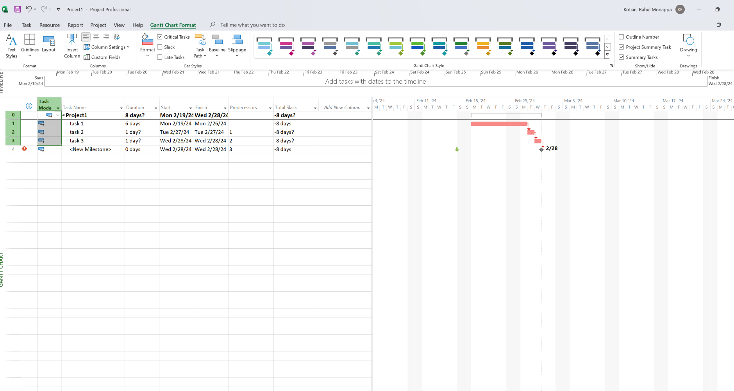

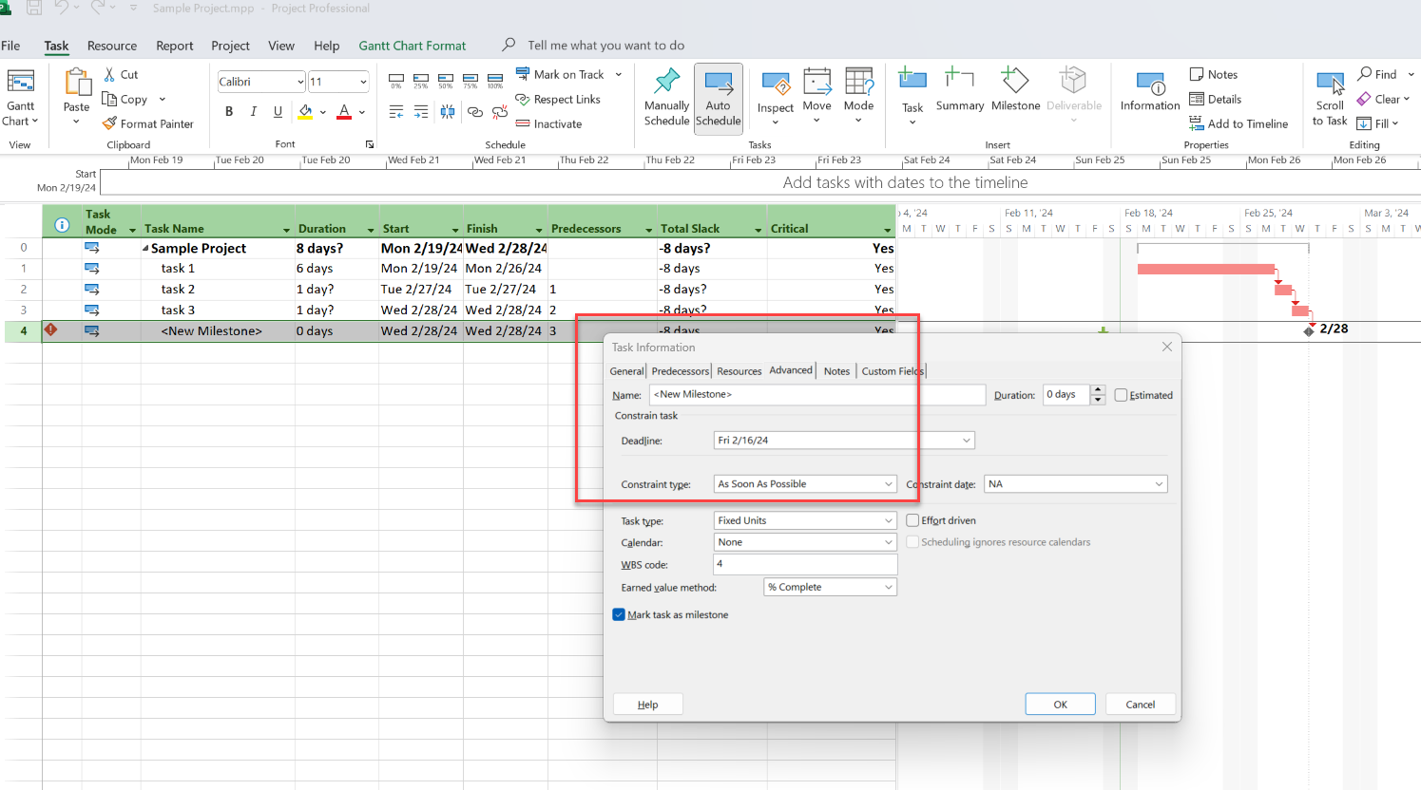

**What are the benefits of having few tasks on the critical path?**

Fewer tasks on the critical path means we have the flexibility to work on the task efficiently and even if there are some delays due to unforeseen conditions, we can still manage the project well due to available slack.

**Is it possible for every task in a project to be on the critical path?**

**Yes.** As we see in the example below, if each task is dependent on its previous task there is a possibility that all of them are in the critical path.

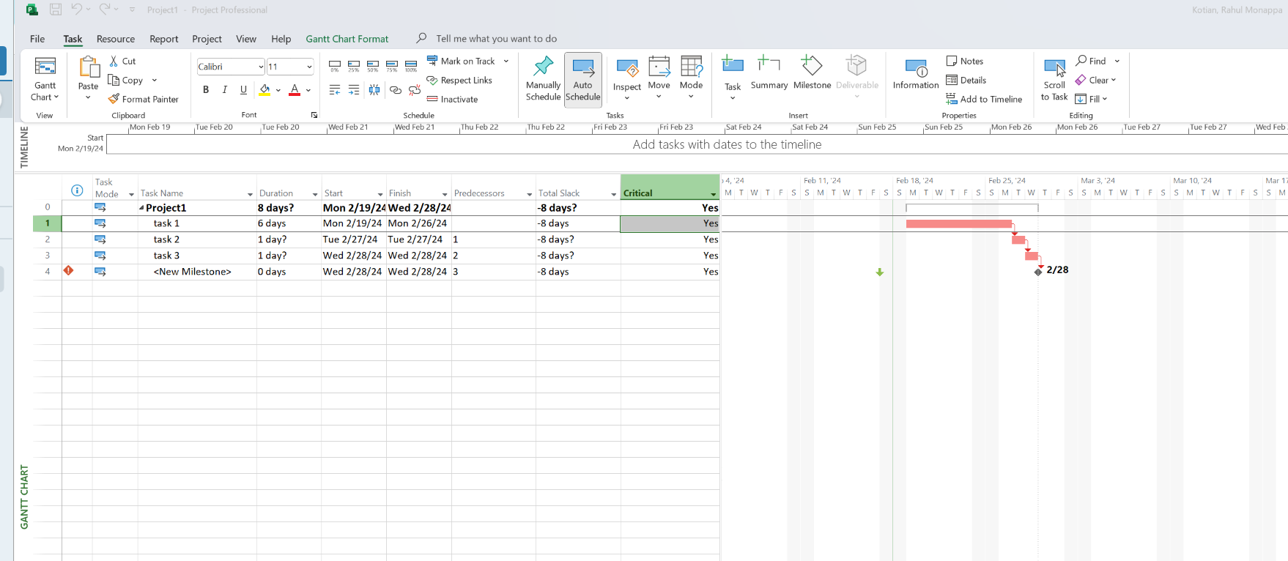

**If so, what are the consequences for a project manager?**

1. Schedule Flexibility
   * 1. The critical path represents the minimum time required to complete the project. Without any slack, there is no flexibility to absorb delays in individual tasks without delaying the overall project. Any unexpected issues or delays on the critical path can directly impact the project's timeline
2. Resource Management
   * 1. With no slack, resource constraints or disruptions can have a more immediate impact on the project schedule. Project managers must carefully manage resources to ensure that they are allocated efficiently and that any issues are addressed promptly
3. Impact on Project Success
   * 1. The risk of not meeting project deadlines is higher when all paths are critical. This can impact project success criteria, stakeholder satisfaction, and potentially harm the reputation of the project manager and the project team.
     2. Changes to project scope, requirements, or objectives become more challenging to manage without schedule flexibility. Adapting to changes while keeping the project on track requires careful planning and execution.